Microsoft

Power Platform Solution Architect

**Training**

Power Platform Trial Setup Instructions

Copyright © Microsoft

**Content**

Introduction to the Labs 3

Objectives 3

Purpose 3

Preparation 3

Resources 3

Implications of using a cloud service 3

Location of files 3

Credentials 3

Profiles or InPrivate/Incognito Mode 3

Trial Setup 5

Trial tenant 5

Objectives 5

Steps 5

Lab Setup 8

Objectives 8

Steps 9

# Introduction to the Labs

## Objectives

### Purpose

The purpose of the hands-on labs is to reinforce learning.

### Preparation

To execute the labs, you need access to a Power Platform environment where you have access to create apps.

### Resources

The labs utilise a Microsoft 365 tenant with:

**Power Apps**: A Software-as-a-Service (SaaS) application platform that enables power users in line of business roles to easily build and deploy custom business apps.

**Microsoft Dataverse**: Make it easier to bring your data together and quickly create powerful apps using a compliant and scalable data service and app platform that integrates into Power Apps.

### Implications of using a cloud service

The user interface and functionality in Microsoft 365 and Power Platform are subject to change without notice so the steps listed may not be correct. In addition, Power Platform may have changed and so there may be differences in the steps.

### Location of files

Files are in GitHub <https://github.com/MicrosoftLearning/MB-600-Dynamics-365-Power-Platform-Solution-Architect/tree/master/Allfiles>

### Credentials

**IMPORTANT** Do not use your own company credentials or company name when creating a trial. We recommend using a Gmail or Outlook address rather than your work email address to prevent your trial being associated with your company.

If you do not have an Outlook.com email address, then you must create an Outlook account before attending in person training as Microsoft blocks multiple account creations from the same location on the same day.

### Profiles or InPrivate/Incognito Mode

One of the issues faced with trials is credential “leakage” where you suddenly find yourself in your company’s Microsoft 365 live tenant and environment.

You have two options:

1. Use InPrivate (Edge) or Incognito (Chrome)
2. Create a Profile (Edge) or add a Person (Chrome)

Note: InPrivate/Incognito does not store session cookies, and this can cause authentication issues with constant login prompts.

How to create a person <https://support.google.com/chrome/answer/2364824>

How to create a profile <https://www.onmsft.com/how-to/how-to-use-profiles-a-new-feature-in-microsoft-edge-insider> or <https://www.tenforums.com/tutorials/144642-how-add-profile-microsoft-edge-chromium.html#option1>

# Trial Setup

If you are using an Authorized Lab Hoster (ALH) environment where a trial environment is provided then skip to the Lab Setup section, otherwise follow the instructions below to create a trial tenant.

## Trial tenant

### Objectives

Create a Power Apps trial.

### Steps

#### Sign up for a trial

In a browser profile session, navigate to

[https://signup.microsoft.com/Signup?OfferId=83D3609A-14C1-4FC2-A18E-0F5CA7047E46](https://signup.microsoft.com/Signup?OfferId=83D3609A-14C1-4FC2-A18E-0F5CA7047E46,B07A1127-DE83-4a6d-9F85-2C104BDAE8B4)

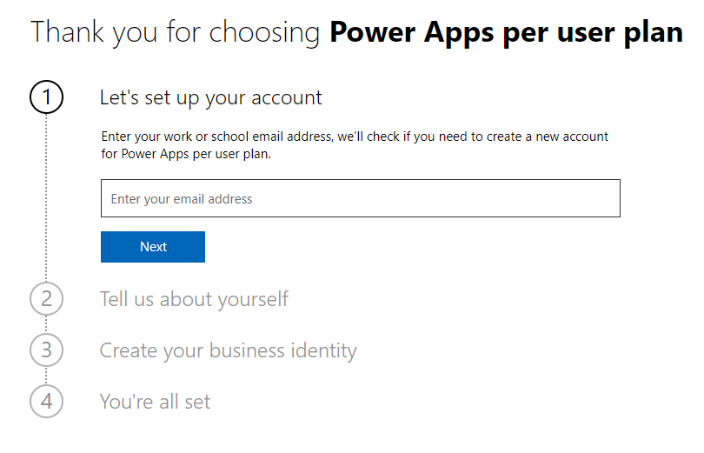

For this screen, use a valid email address (**not your business email address**) where you can receive credentials and password resets, and a valid mobile phone number. If you are already using Microsoft 365 then use another email address e.g., outlook.com or gmail.com.

Click **Next** and then **Setup account**.

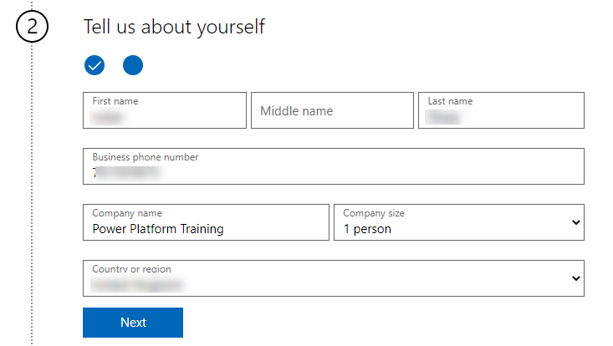

Fill out the form above.

For Company Name, use **Power Platform** **Training**.

For Your organisation size, select **1 person.**

Note: We recommend using English as language as this makes following the labs much easier.

Click **Next**.

Select the **Text me** radio button, enter your mobile number and click **Send Verification Code**.

Enter the unique verification code you received and click **Next**.

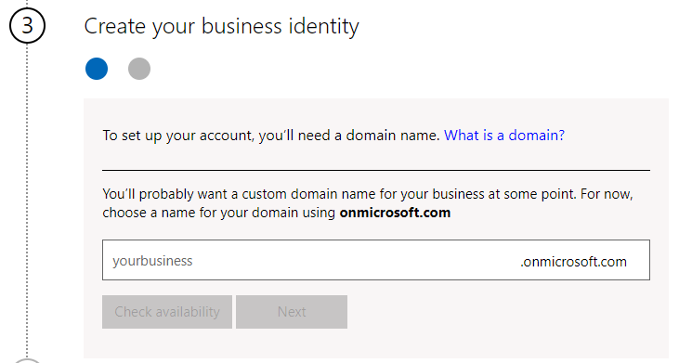

Fill out the form above

For the organisation name, enter a unique name to reflect this training e.g., your initials + year/month.

Click **Check availability**.

Click **Next**.

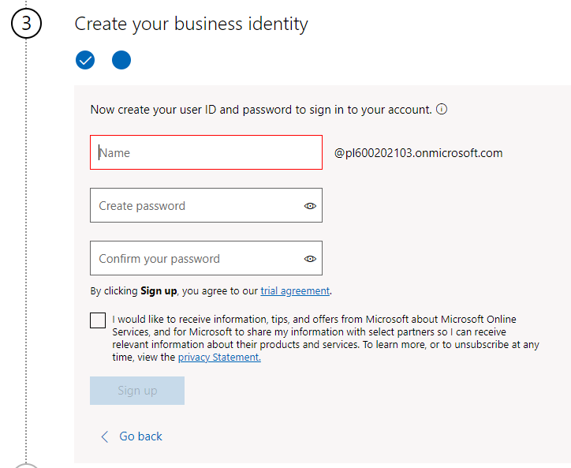

Fill out the form above.

Click **Sign up**.

After a short while the following page will appear.

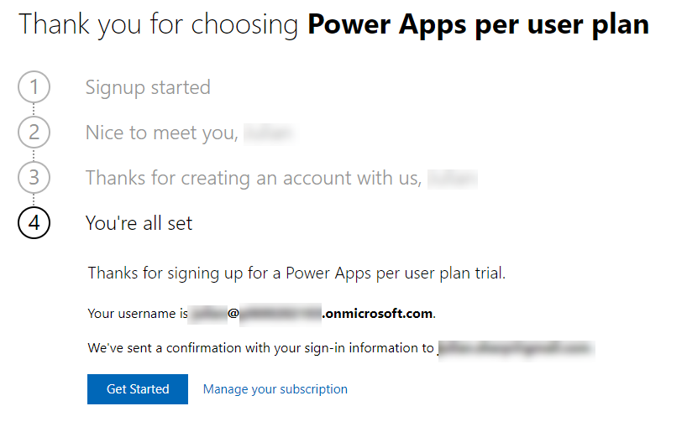

Write the user ID down.

Click **Get Started**

#### Configure Microsoft 365

This will transfer control to the Microsoft 365 environment. (A few minutes and refreshes maybe needed to get the screens below.)

These next few screens may be different as Microsoft regularly changes the sign-up process. You need to access the Microsoft 365 Admin Centre <https://admin.microsoft.com/AdminPortal/Home>

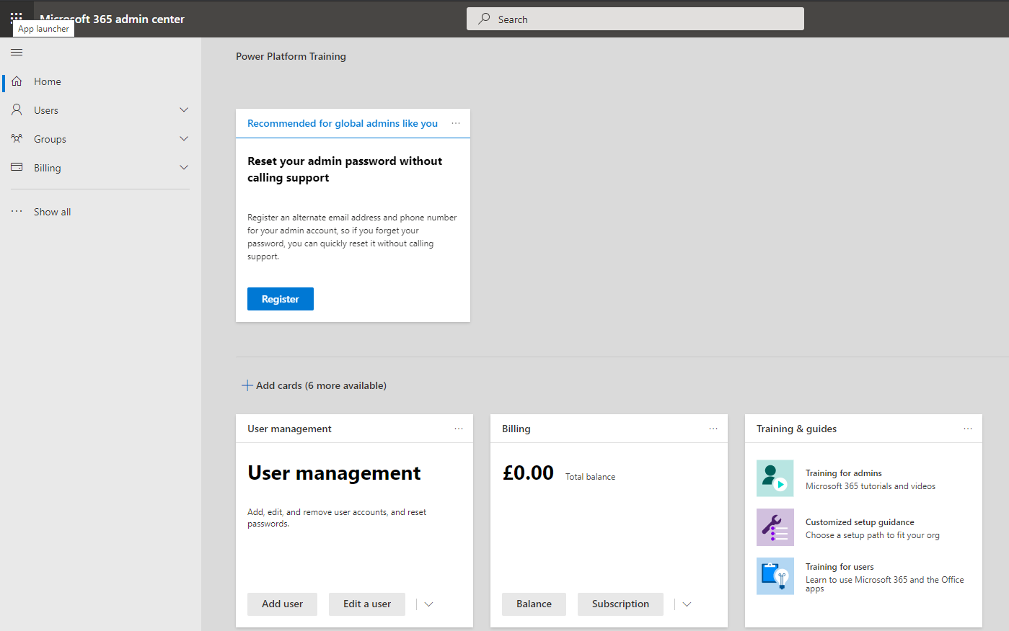

Click **Users** and then **Active Users** in the left hand navigation

Verify that your users has all licenses assigned

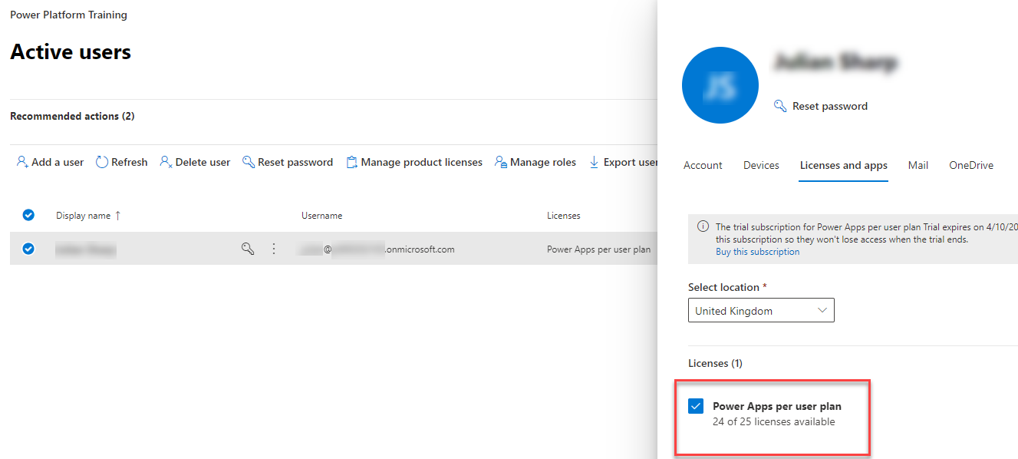

**Close** the pane.

## Lab Setup

### Objectives

Create users and environments for all students.

### Steps

#### PowerShell Script

In Windows, open Windows PowerShell. Make sure you open PowerShell as an administrator. See <https://docs.microsoft.com/en-us/powershell/scripting/learn/ps101/01-getting-started#how-do-i-launch-powershell> for how to start PowerShell.

Note: You can use the PowerShell command line or PowerShell ISE.

Change Directory to where the Setup.ps1 and ContosoDeviceOrderManagement_1_0_0_1.zip files are located.

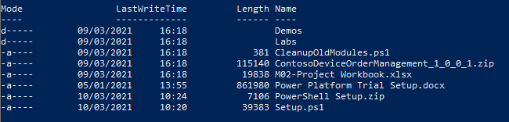

Run the following commands:

**Set-ExecutionPolicy RemoteSigned**

**Set-PSRepository -Name PSGallery -InstallationPolicy Trusted**

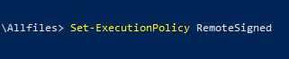

If prompted answer with **A [Yes to All]**

Run **Setup.ps1**



If prompted answer with **A**

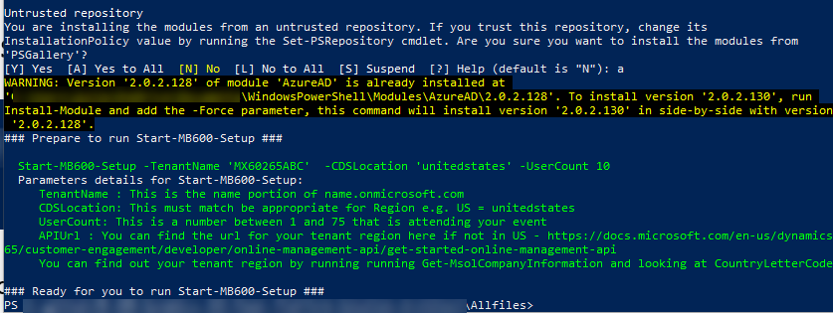

Run the following command:

**Start-MB600-Setup -TenantName <Tenant name> -CDSLocation <Region> -UserCount <Number of Students>**

Your Tenant name is the name you entered for Step 3 when creating the trial or will be the name provided by your lab hosting environment. You should enter only the first part of the Tenant name i.e., without onmicrosoft.com.

The region should be the region of your tenant and will be from the country you selected in Step 2. You can find your region by running the commands:

**Connect-MsolService**

**Get-MsolCompanyInformation**

And checking the country code. Valid values for Region are:

* unitedstates
* southamerica
* canada
* europe
* asia
* australia
* japan
* india
* unitedkingdom
* France

The script creates environments and databases for each student and a development environment with the

#### Check Dataverse Environments

Navigate to the Power Platform Admin Center <https://aka.ms/ppac>

Verify that there are environments for each student.

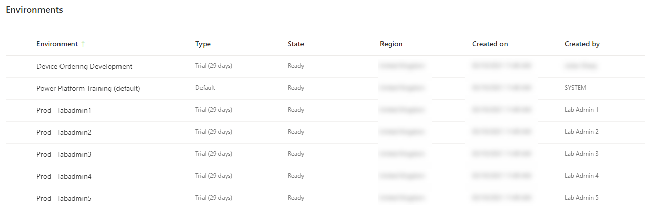

#### Check Development Environment

Navigate to the Maker Portal <https://make.powerapps.com/>

Select the **Device Ordering Development** environment.

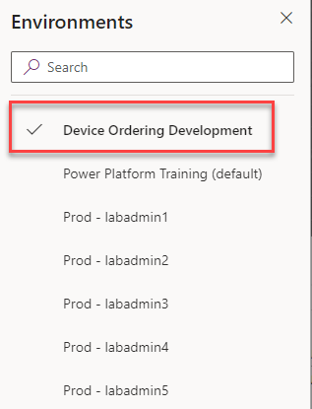

If you do not see the environment, press Ctrl-F5 to refresh your browser.

Click on **Solutions** and verify the **Contoso Device Order Management** solution is imported.

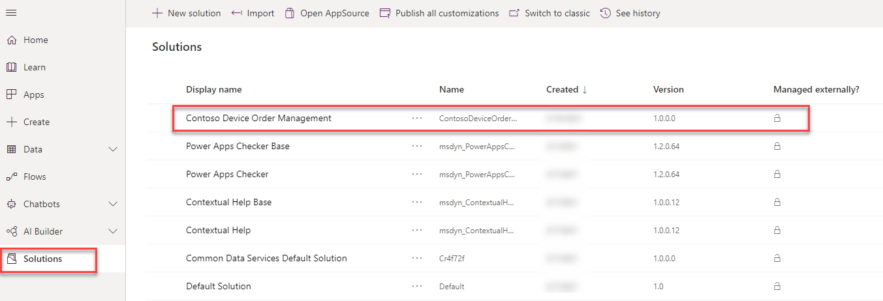

Click on **Apps** and verify the **Device Ordering App** and the **Device Procurement** apps have been imported.

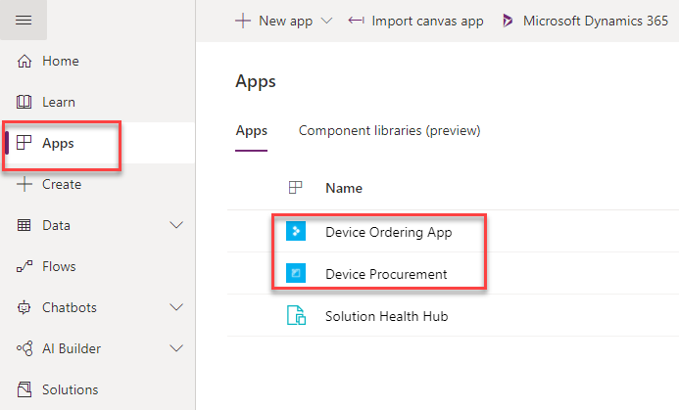

You are now ready to run the ALM lab.